CODE
<!DOCTYPE html>
<html>

<head>
<title>Biography of Dr. A.P.J. Abdul Kalam</title>
<style>
body {
background-color: azure;
font-family: cursive;
line-height: 1.6;
text-align: center;
}

blockquote {
background-color: aliceblue;
border-left: 5px solid black;
padding: 15px;
font-style: italic;
color: black;
}

table {
background-color: blanchedalmond;
width: 100%;
border-collapse: collapse;
}

th,
td {
padding: 10px;
text-align: center;
border: 1px solid burlywood;
}
</style>
</head>

<body>

<h1>Dr. A.P.J. Abdul Kalam: <i>A Journey of Inspiration</i></h1>

<!-- Image of Dr. Kalam -->
<img src="kalam.jpeg"></img>

<!-- Biography quote -->
<blockquote cite="https://kalamcentre.com">
<p>"Dream, dream, dream. Dreams transform into thoughts and thoughts result in action."</p>
</blockquote>

<h2>Introduction</h2>
<!-- Intro text -->
<p><strong><mark>Dr. Avul Pakir Jainulabdeen Abdul Kalam</mark></strong> (1931–2015) was a <b>distinguished</b>
<i>Indian</i> aerospace scientist and the <strong><mark>11th President of India</mark></strong>. Widely revered
as the <strong><mark>"Missile Man of India,"</mark></strong> he played a <i>foundational</i> role in the
nation's civilian space program and military missile development.
</p>

<h2>Words of Wisdom</h2>
<!-- Wisdom quote -->
<blockquote cite="https://kalamcentre.com">
<p>"To succeed in your mission, you must have single-minded devotion to your goal."</p>
</blockquote>

<h2>Quick Facts</h2>
<!-- Quick facts table -->
<table>
<tr style="background-color: darkkhaki;">
<th>Attribute</th>
<th>Details</th>
</tr>
<tr>
<td><strong>Full Name</strong></td>
<td><mark>Avul Pakir Jainulabdeen Abdul Kalam</mark></td>
</tr>
<tr>
<td><strong>Lifespan</strong></td>
<td><mark>15 October 1931 – 27 July 2015</mark></td>
</tr>
<tr>
<td><strong>Birthplace</strong></td>
<td><mark>Rameswaram, Tamil Nadu, India</mark></td>
</tr>
<tr>
<td><strong>Nicknames</strong></td>
<td><mark>"Missile Man"</mark>, <mark>"People's President"</mark></td>
</tr>
<tr>
<td><strong>Major Awards</strong></td>
<td><mark>Bharat Ratna (1997)</mark>, <mark>Padma Vibhushan (1990)</mark></td>
</tr>
</table>

<h2>Early Life and Education</h2>
<!-- Early life details -->
<p>Born into a <b>humble family</b> in Rameswaram, Dr. Kalam learned the value of <strong><mark>hard
work</mark></strong> early in life.</p>
<ol>
<li><strong>Early Struggles:</strong> Worked as a <i>newspaper boy</i> to support his family.</li>
<li><strong>Academic Excellence:</strong> Earned a degree in <b>Physics</b> from <em>St. Joseph's College</em>.
</li>
<li><strong>Specialized Engineering:</strong> Graduated in <b>Aerospace Engineering</b> from the <em>Madras
Institute of Technology</em>.</li>
</ol>

<h2>Scientific Legacy</h2>
<!-- Legacy details -->
<dl>
<dt><strong><mark>ISRO & Space Exploration</mark></strong></dt>
<dd>Played a <i>critical</i> role in the development of India's space program and was the project director for
the <b>SLV-III</b>.</dd>

<dt><strong><mark>Defense & Missiles</mark></strong></dt>
<dd>Spearheaded the <i>Integrated Guided Missile Development Program</i>, resulting in missiles like
<em>Agni</em> and <em>Prithvi</em>.
</dd>
</dl>

<h2>The People's President</h2>
<!-- Presidency details -->
<p>Serving as President from <strong><mark>2002 to 2007</mark></strong>, he became known as the
<strong><mark>"People's President."</mark></strong>
</p>

<p>Legacy: Even after his passing in 2015, his books like <em><mark><b>Wings of Fire</b></mark></em> continue to
inspire millions. You can learn more about his life at the <a href="https://kalamcentre.com"
target="_blank">official Kalam Centre website</a>.</p>

<p><small><em>Disclaimer: This content is provided for educational and informational purposes only.</em></small></p>

</body>

</html>

OUTPUT
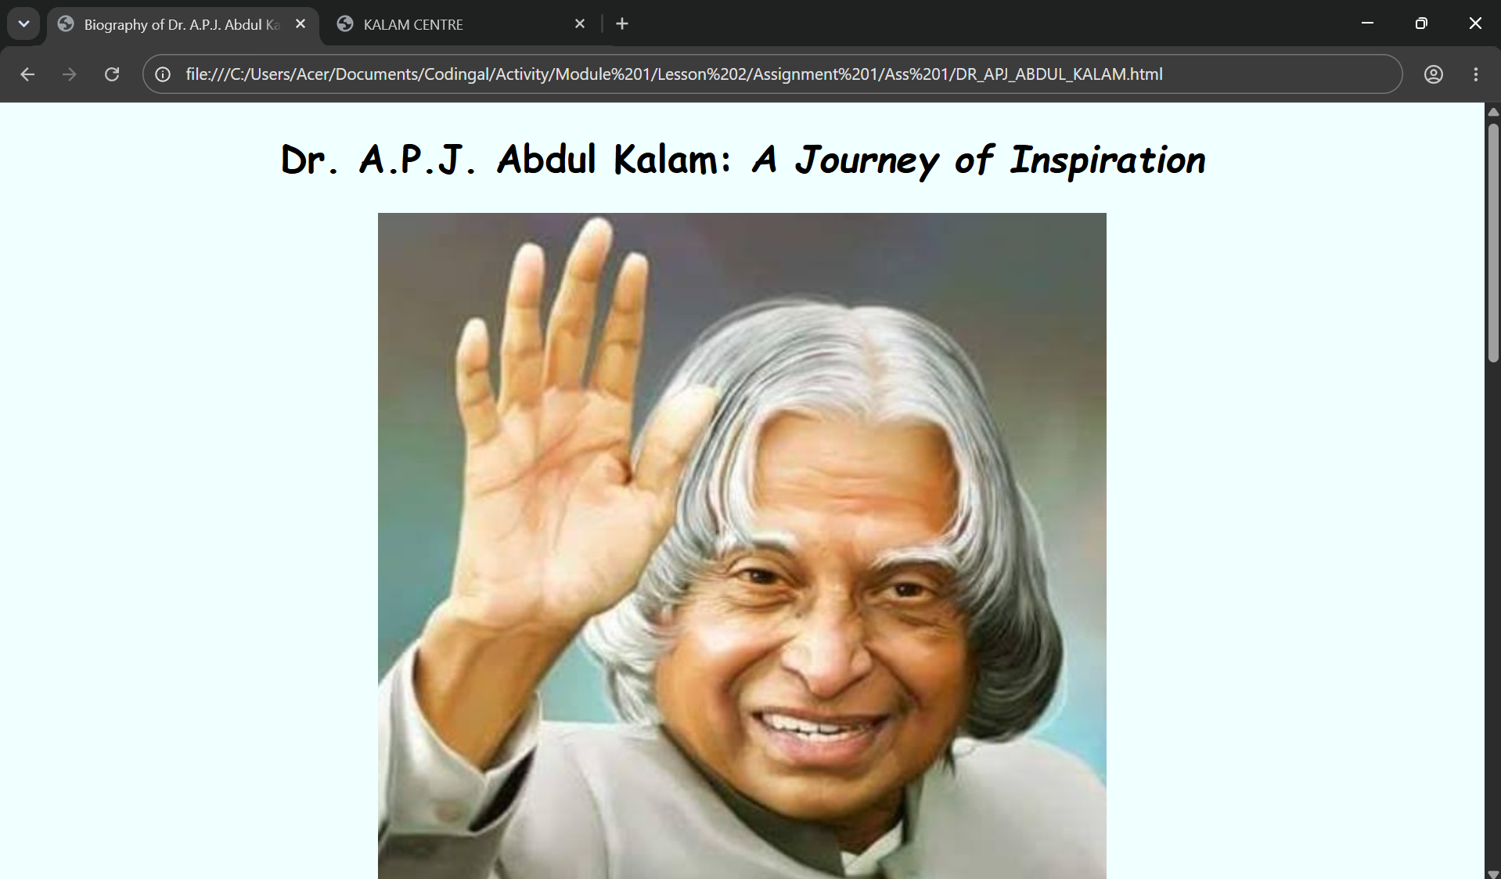
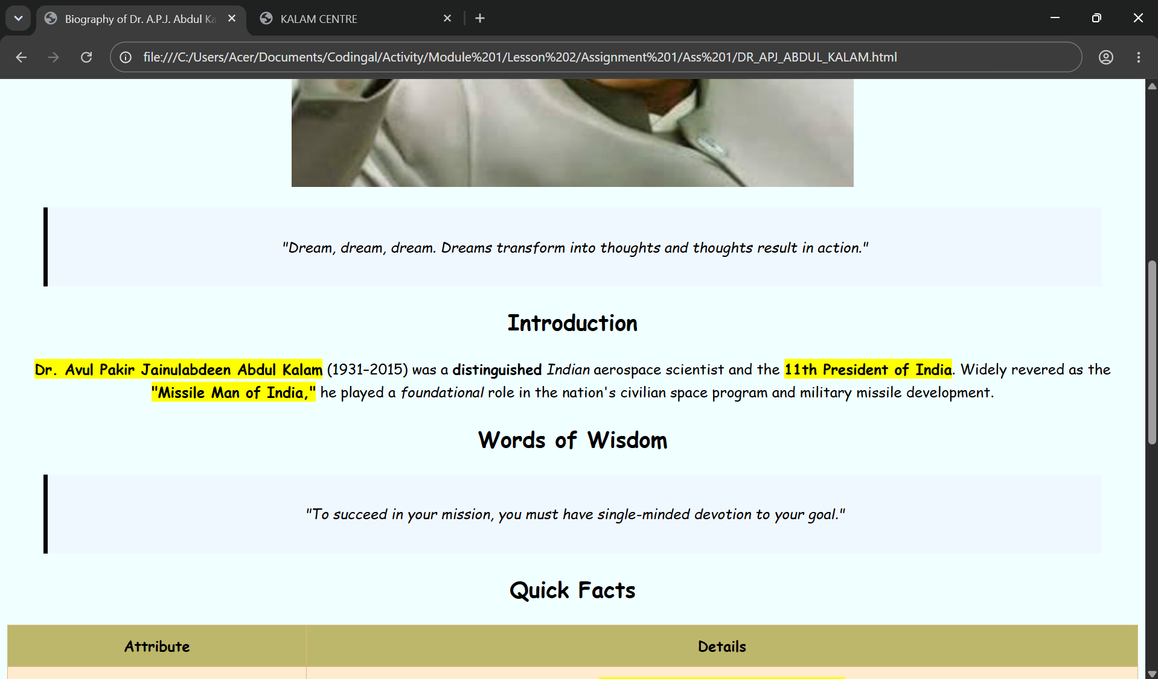
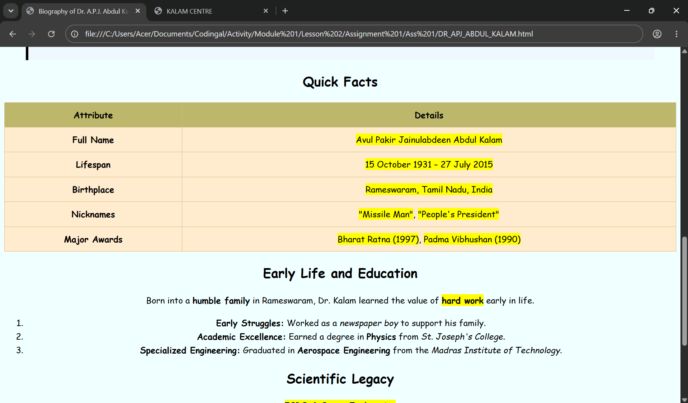
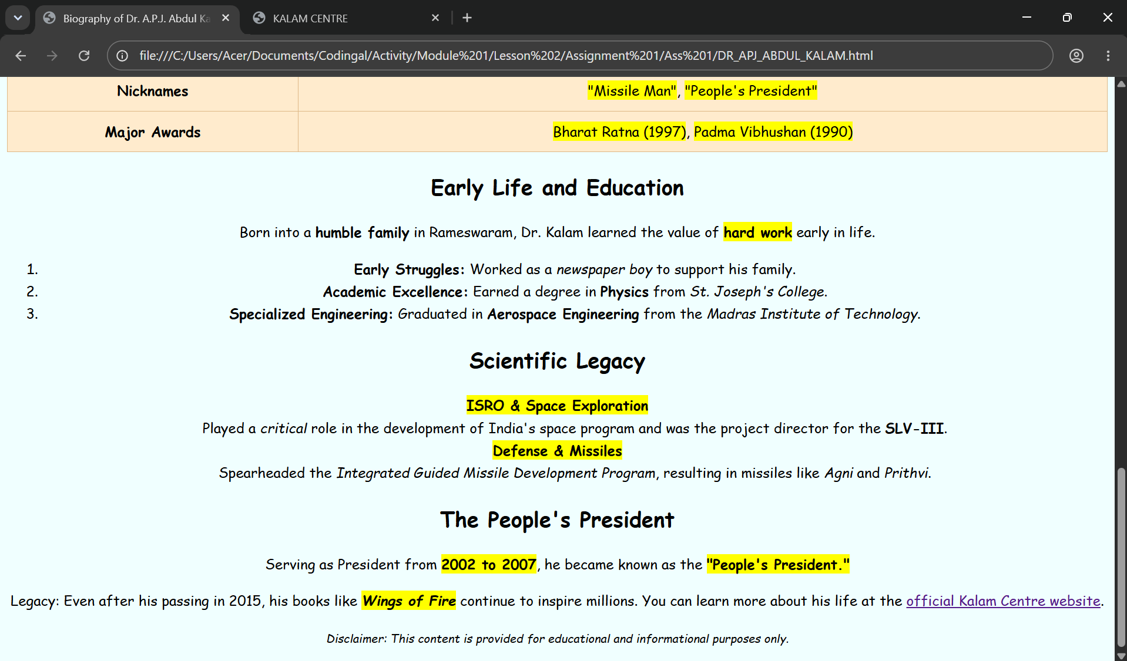
<a>TAG LINK

https://kalamcentre.com/

